ETD guide for formatting tables

This guide is to help with formatting tables in a dissertation. If there is a table that is in landscape and you would like it to be in portrait, follow these steps.
- Start by highlighting the table.
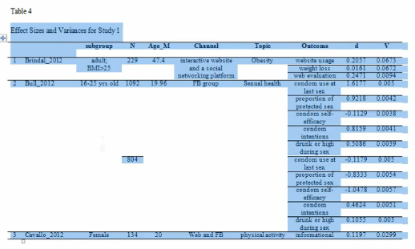

- Right Click and select Copy

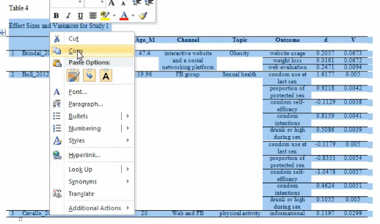

- Click the ‘Insert’ ribbon
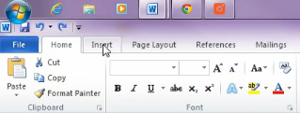

- Select ‘text box’
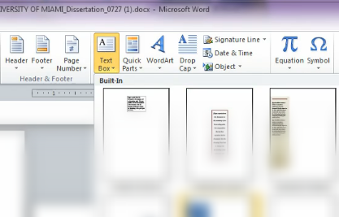

- Click ‘Draw Text Box’

- Draw the text box to the desired size on the page.
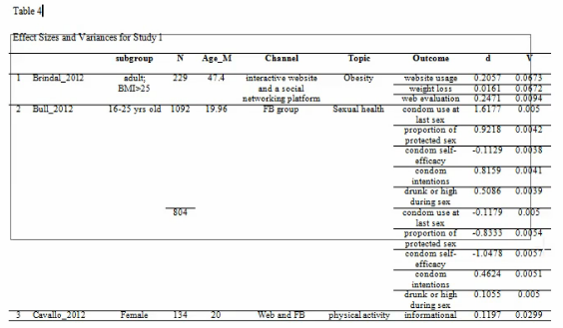

- After drawing the table, right-click and paste the table into the newly-created text box.
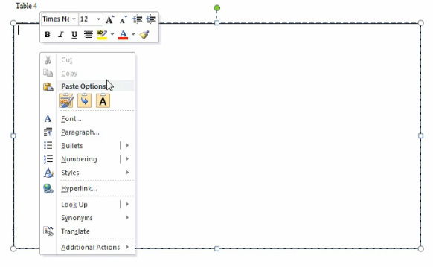

- Next, select the green ball at the top of the table and rotate it.

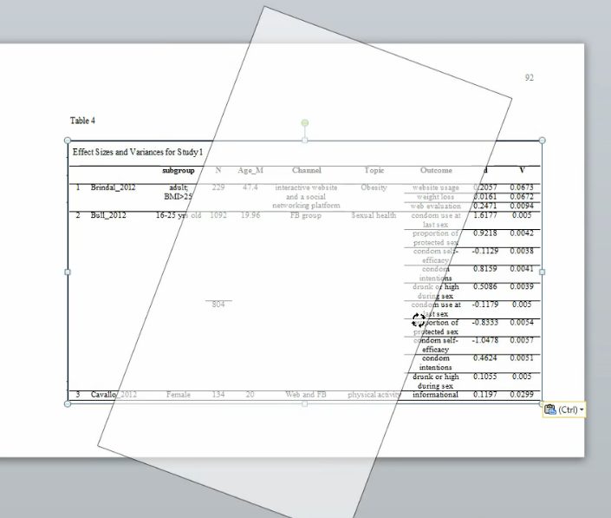

- Resize the table as necessary

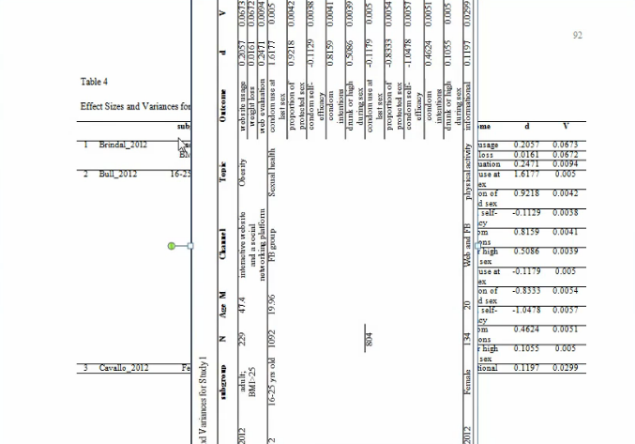
- To change the layout of the page, select the page you would like to change, click on the ‘Page Layout’ menu

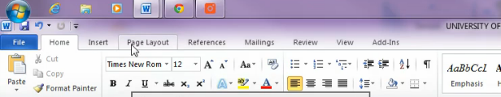

- Next, click on Orientation and select ‘Portrait’

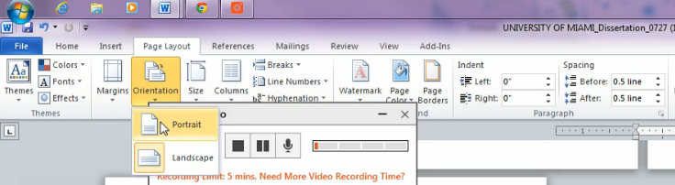

- Lastly, select your table and resize it to fit the page.
