MediaMark MRI

How to Access and Register

Go to library.miami.edu
Click on “Databases”
Type in “MRI”

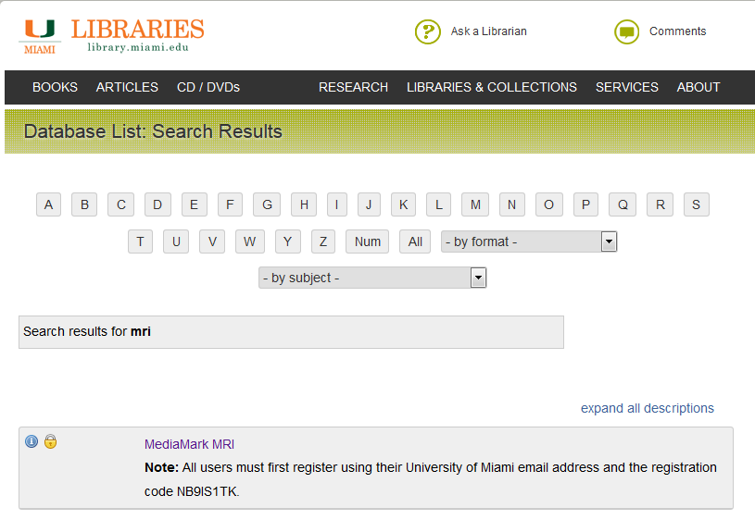
Click on “MediaMark MRI”
XXXXXXX
Note down the registration code if needed.

The registration code will change every six months in January and July. All users must re-register every six months.
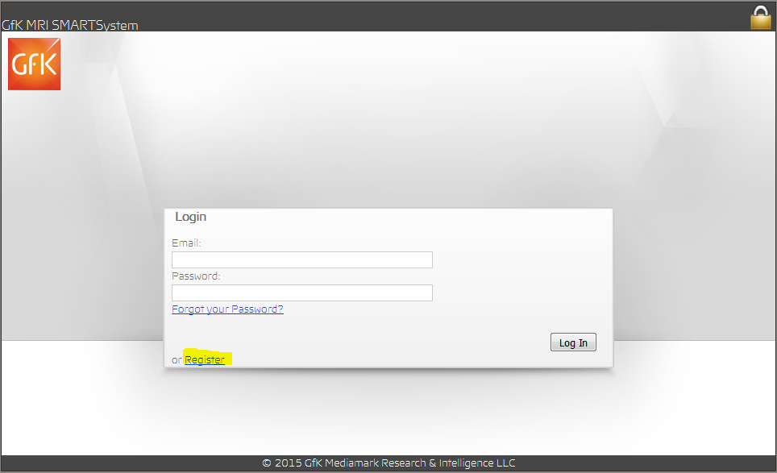
Step 1: Create your own user account by clicking on “Register.” You will need the registration code mentioned above.

You must register using a University of Miami email address;
For example: jdoe@umiami.edu

Step 2: You will receive a confirmation email. Click on the link to create a password and activate your account. You may now come back to this page and login.

Now, you can start working.
jdoe@umiami.edu
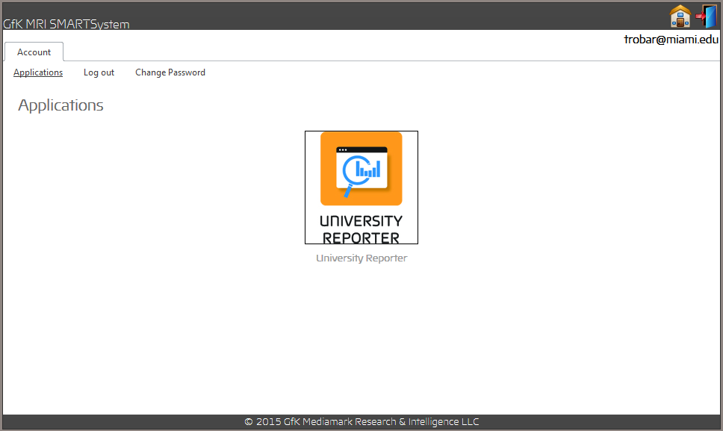
Click on “University Reporter.”

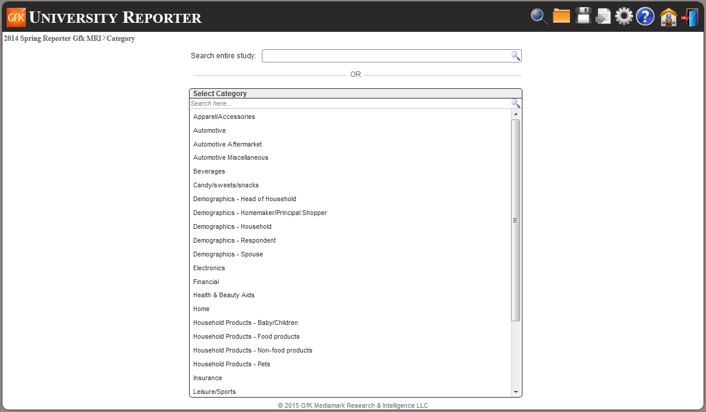
We can search the latest available report only. Later, you will see how to access older data.

You may choose a report such as “Electronics.”

OR

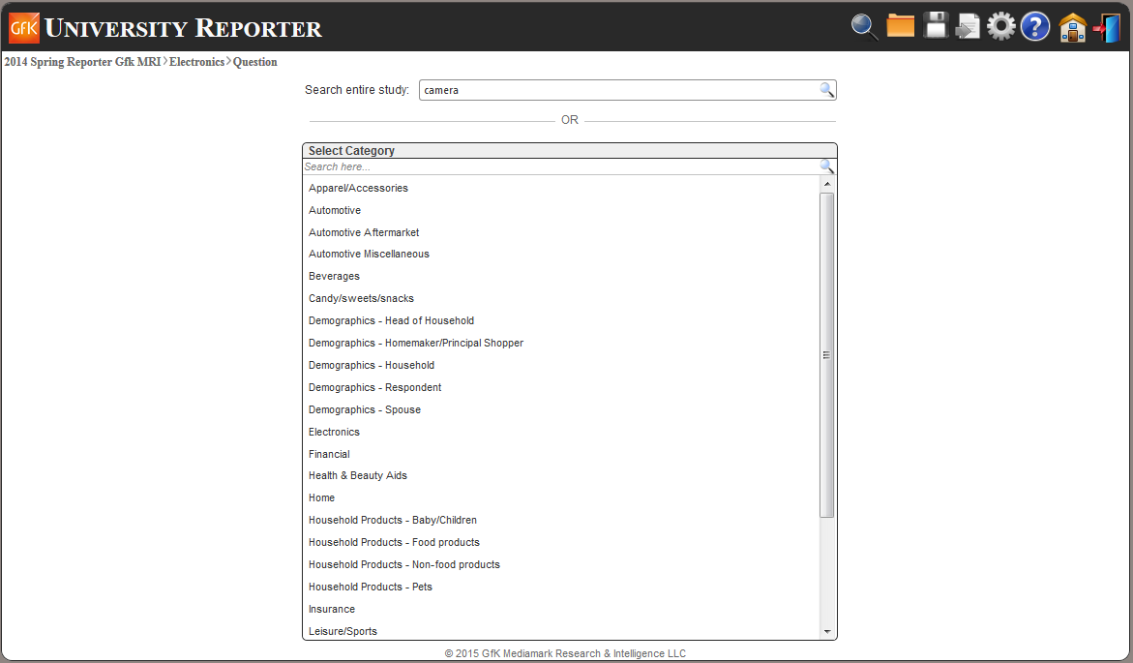
For more direct results, search by keyword.
Use a single keyword, not a phrase.
Use the singular, not plural, word in order to get the most comprehensive results.

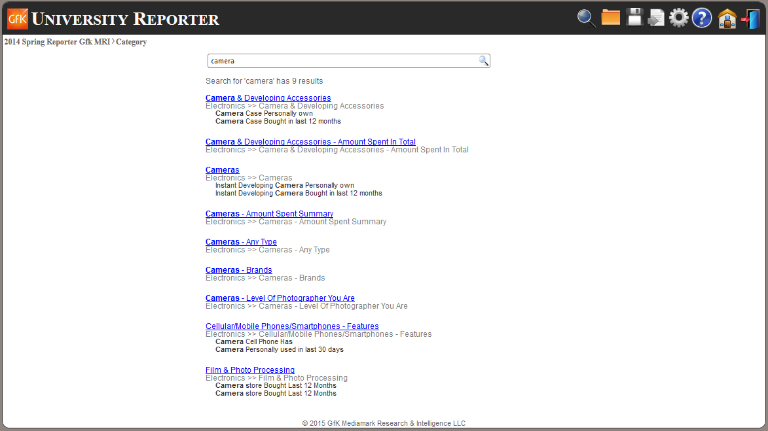

The system will respond with a list of reports that contain your keyword. You still might not see the exact category that you’re looking for and will need to explore these options further in order to find it. For instance, if you were looking for digital cameras, it doesn’t show up on this page but, if you click on the third entry “Cameras,” you will get the screen below.
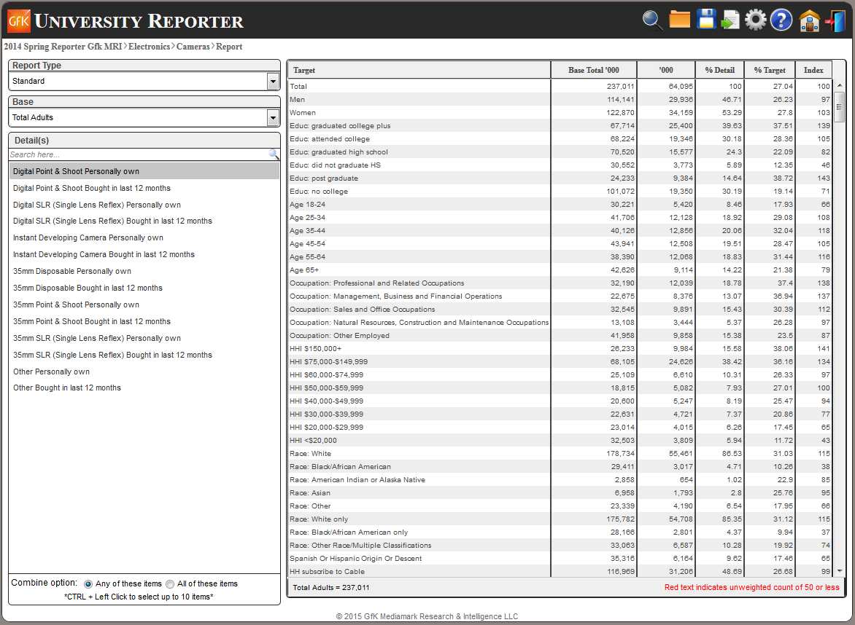

The first four entries are all about digital cameras. They didn’t show up on the previous screen because none of these lines actually contains the word “cameras.”

The columns of figures at the right are a Standard Report. If you wish to compare across the latest three years, change Standard to Trend and you will see the screen below. The second column above is the same as the first column below.

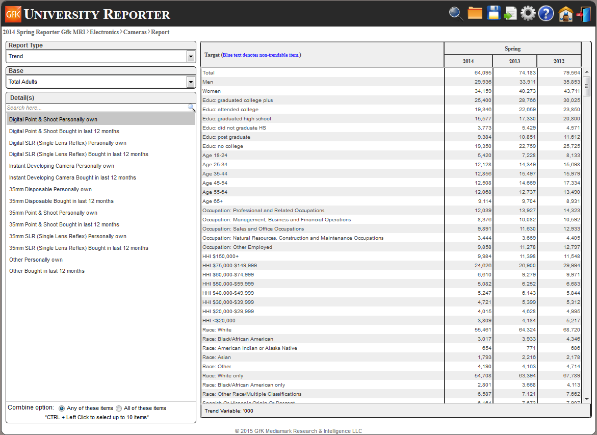
Let’s go back to a Standard Report.

The Base is the group of people reflected in the report. Total Adults is all people in the U.S. who are 18 yrs. of age and older.
You may change this to just men, just women, principal shoppers, and those 21 yrs. and older.

Details is a list of all the reports available from this page. Click on whichever one best describes the group of people that you want to learn about.
You may also combine up to 10 of these into a single report.
You may only combine reports with the same subheading. You could combine any of the “Personally own” but you cannot combine “Personally own” with “Bought in last 12 months.”

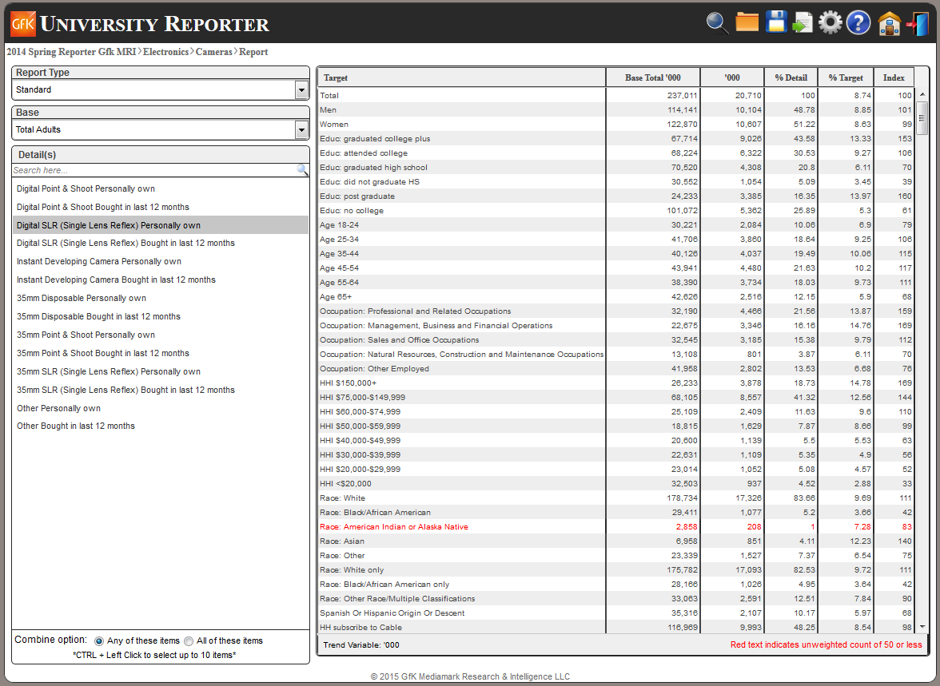
Some lines of these reports are printed in red. The data on these lines is unreliable because the sample size was too small. You should disregard these lines.

How To Read a MediaMark Report

Column 1: Base Total ‘000

The ‘base total’ refers to the base group that you have chosen at the left; in this case, Total Adults.

In any report that has the same base group, the Base Total column will remain the same. The numbers in the Base Total Column will always be the same for Total Adults regardless of what report you are looking at.

The numbers in this column will only change if you change the base group; if, for instance, you change your base group to “Men.”

Base Total is the total number of people in your base group in the United States at the time the report was created; in this case, Spring 2014.

The title of this column is “Base Total ‘000.” The “ ‘000” is very important! It means that, in order to save space, they have rounded all numbers to the nearest thousandth and removed the last three zeros. You must remember to add those zeros back on.

The second number showing in this column is 114,141. In the left or Target column, this line is marked “Men.” This means that in the Spring of 2014, the total number of adult males in the U.S. was 114,141,000.

How To Read a MediaMark Report

Column 2: ‘000

This column give the demographics for the report that you have chosen at the far left.

The title of this column is “ ‘000.” The “ ‘000” is very important! It means that, in order to save space, they have rounded all numbers to the nearest thousandth and removed the last three zeros. You must remember to add those zeros back on.

The second number showing in this column is 29,936. In the left or Target column, this line is marked “Men.” This means that in the Spring of 2014, the total number of adult males in the U.S. that personally owned a digital point & shoot camera was 29,936,000.

How To Read a MediaMark Report

Column 3: % Detail

This column tells you what percent of the total number of people in this report (1st figure, column 2) match the detail that you have selected.

Let’s say that you are looking at the age group of 18-24. There are 5,420,000 people of that age who personally own a digital point & shoot camera. There are 64,095,000 in total who own one.
5,420,000 / 64,095,000 = 8.46

Of all the people who own these cameras, only 8.46% are between 18 and 24 years of age.

How To Read a MediaMark Report

Column 4: % Target

This column tells you what percentage your target group comprises out of all such people in the U.S.

Let’s say that you are looking at people who graduated from college; they are your target group. In that group, there are 67,714,000 adults in the U.S. Of those, 25,400,000 personally own this type of camera.

25,400,000 / 67,714,000 = 37.51

College graduates who own this type of camera represent 37.51% of all adults in that group.

How To Read a MediaMark Report

Column 5: Index

The index is the easiest column to read. Basically, they’ve combined columns 3 and 4 into easy numbers.

100 is normal. If the number is higher than that, then the corresponding target group is more inclined to own this type of camera. If the number is lower, the group is less likely to own it.

